Ax`

Project Report

On

**“Home Service Provider”**

Submitted by

**Mast. Dhanraj Viresh Swami [6371]**

**Mast. Shubham Santosh Shete [6367]**

B.Sc. (ECS)- III

Under the guidance of

**Mr. Pravinkumar Birajdar**



Department of Management and Computer Science

Sangameshwar College,

Solapur

2020-2021

## LOGO1Shri Sangameshwar Education Society’s

## SANGAMESHWAR COLLEGE, SOLAPUR

## Reaccredited by NAAC with ‘A Grade’ (CGPA 3.39)

## Kannada Linguistic Minority Institution

**DEPARTMENT OF MANAGEMENT AND COMPUTER SCIENCE**

**CERTIFICATE**

This is to certify that

**Name Exam Seat no**

**1. Mast. Dhanraj Viresh Swami [6371]**

**2. Mast. Shubham Santosh Shete [6367]**

Are students of Sangameshwar College have successfully completed a Project Report entitled ***“*Home Service Provider*”*** in partial fulfilment of Bachelor of Computer Science (Entire Computer Science)as prescribed by Punyashlok Ahilyadevi Holkar Solapur University, Solapur for the Academic Year 2020-21.

|  |  |  |
| --- | --- | --- |
| **Project Guide** | **External Examiner** | **Director** |
| **Mr. Pravinkumar Birajdar** |  | **Miss. Kadadi J. J.** |

**Declaration**

We are the undersigned students of B.Sc.[ECS] – III Sem VI hereby declare that, the project report entitled,

“**Home Service Provider**”

Written and submitted by us is our original work. The empirical binding in this report is based on the data collected by us, while preparing this project report.

Name of Students Signature

Mast. Dhanraj Viresh Swami

Mast. Shubham Santosh Shete

Place: Solapur.

Date:

**ACKNOWLEDGEMENT**

It is a fortune to find opportunity to express my deep sense of gratitude to all those people who helped us with their guidance and assistance, without which the project would not be possible. Their contribution has been invaluable.

First, I would like to extend my heart-felt gratitude and respect, to our parents, who have always been a tremendous source of encouragement and inspiration for me.

Last but not the least, I would like to thank the Almighty without whose blessing, I would not have reached the goal.

**Mast. Dhanraj Viresh Swam**

**Mast. Shubham Santosh Shete**

(B. Sc. (ECS) – III)

**PREFACE**

The well planned; properly executed the utility titled “**Home Service Provider**” is software developed for provides all kinds of domestic services to the users like electrician, plumber, carpenter, etc... People can easily find the service providers for daily repairing of household things. These projects have been developed using ASP.NET 4.0 (C#) with SQL EXPRESS 2008. This is user friendly, easy to use, understandable and satisfies all user requirements.

There is no doubt that in spite of strenuous efforts, errors might remain in the text. I truly apologize for that.

**INDEX**

|  |  |  |  |
| --- | --- | --- | --- |
| **SR. NO.** | **CHAPTER DETAILS** | | **PAGE NO.** |
|  | | | |
| **1** | **INTRODUCTION** | |  |
|  | 1.1 | Project Overview |  |
|  | 1.2 | Existing System |  |
|  | 1.3 | Proposed system |  |
|  | 1.4 | Scope of the Project |  |
|  | | | |
| **2** | **FEASIBILITY STUDY** | |  |
|  | 2.1 | Project Feasibility |  |
|  | 2.2 | Hardware Specification |  |
|  | 2.3 | Software Specification |  |
|  | | | |
| **3** | **SYSTEM DESIGN** | |  |
|  | 3.1 | DFD |  |
|  | 3.2 | ERD |  |
|  | 3.3 | Database Design |  |
|  | 3.4 | Output Screen |  |
|  | | | |
| **4** | **IMPLEMENTATION** | |  |
|  | 4.1 | Code Script |  |
|  | | | |
| **5** | **TECHNOLOGY AND TOOLS** | |  |
|  | | | |
| **6** | **BIBLIOGRAPHY** | |  |

1. **Introduction:**

Labours Services Provider is web-based application. This website provides all kinds of domestic services to the users like electrician, plumber, carpenter, etc... People can easily find the service providers for daily repairing of household things. This system contains high authentication service for users, service providers and administrator. This system provides facility to the common people by which they get all kinds of services on single platform. This system is easy to understand for user and service providers.

**1.1 Features:**

Allows labours and user to sign in. We manage different types of services in different categories for users. The information about service providers (name, contact no., profession name is easily available for users. Providers can create their own account and fill their all necessary details in registration form. Users can give the review on all types of services. Users will able to share information about labours through link.

**1.2 Existing System:**

The idea behind Labours Services Providers is new Concept,there are very lessthis type of existing system. The service provider has to register new labours for services manually. In this type of system everything done manually. The service provider has to arrange to different categories. They use traditional way, like cards, list diaries and then they record the information in the cards in written and then the information calculated by one person. The labours may able to make changes in their information by the service provider.

For example, Justdial is a company that provides local search for different services in India over the phone and online. A website provides an information that users could call to receive current information about local business listings.

**Problems in Existing System:**

This system follows traditional way so everything is done on paper and pen and it take more time and lots of efforts. Process is so difficult when the number of labours increases.There is risk to maintain this all-important information on paper.If the labours want to make change in his/her information then it is tedious to handle. Service provider has to update the information every time manually. Service provider has to arrange different type of labour services in categories and it’s difficult to arrange every time manually and time consuming.

**1.3 Proposed System**

The proposed system meant to give more easiness to the users that they can search the labours on single touch. One of the objectives of this system is to ‘Keep It Simple’. Also, inappropriate things can be reported to admin so, action can be taken by admin and so this reduces much of those un-necessary things on social platform.Information will be displayed in an easy manner in order to provide user a convenient way to navigate him/herself throughout the web application.The Website is so convienent and simple to use anyone knows about the internet can use easily. Our system plays vital role in today’s life as it has many advantages in our life because it makes convenient in daily life of the people.System will also provide user a contact information of developers so that they can share a feedback regarding improvement of the site.

Our proposed system gives more easy to use for users and service providers. Users can come on our website and create user account. He will see different categories of services providers in our website. According to their need he selected the service provider then he will get service providers information like name, address,contact no.,profession name.User will get his contact number and call the service provider. user can discuss his problem with service provider.As per service provider he gives the service to the user. For service provider,he also come on our website. Hecreatehis account and fill up necessary details in account and provides service to the user. In this way direct coordination between user and service provider is established.The main important role of admin is to handle the data of users and service providers properly and also maintains the website properly.

**Characteristics of Proposed System**

**1.User-friendly**

Some of the existing system provides complicated user interface but our Website is very user-friendly and appropriate in UI (User Interface) and very simple to use. We will be focusing on making simple interface which will help users to use our system without any instructions. There will be no unnecessary additional features which will create confusion.

**2. Security**

Security is always main thing in our systems. Our system will store user data and service providers information securely. System will be kept protected from all malicious attacks. We will be constantly working on improving the security of our system as we go along. User data will be safely encrypted with no data breach.

**3. Information**

We provide trusty and clear information of about labour such as name, their profession, address and contact no. We should keep users active with best service for users and give appropriate information.

**4. New People in city**

Labours service provider is very beneficial for working professionals and also very beneficial for the people who are recently relocated to the city to get correct information about labours for their work.

**1.4 Scope of Project**

This is web-based application so it is having much more scope over the internet. It helps to provide best and reliable services to users .It will be free and easily accessible for users. More features will be added for users as the time goes.

**2. Feasibility Study:**

The basic idea behind feasibility study is to determine whether the project is feasible or not. A feasibility is conducted to identify a best system that meets all the requirements. This includes an identification ,description, an evaluation of the proposed systems and selection of the best system for the job.The requirements of the system are specified with a set of constraints such as system objectives and the description of the out puts. It is then duty of the analyst to evaluate the feasibility of the proposed system to generate the above results. Three key factors are to be considered during the feasibility study.

**2.1 Project Feasibility**

**1.Operation Feasibility:**

An estimate should be made to determine how much effort and care will go into the developing of the system including the training to be given to the user. Usually, people are reluctant to changes that come in their progression. The computer initialization will certainly affected the turn over, transfer and employee job status. Hence an additional effort is to be made to train and educate the users on the new way of the system**.**

**2.Technical Feasibility:**

The main consideration is to be given to the study of available resources of the organization where the software is to be implemented. Here the system analyst evaluates the technical merits of the system giving emphasis on the performance, reliability, maintainability and productivity.

By taking the consideration before developing the proposed system, the resources availability of the organization was studied. The organization was immense computer facilities equipped with sophisticated machines and the software hence this technically feasible.

**Requirements:**

* 1. **Hardware Specification:**
* Operating System:Microsoft Windows 7 or above.
* Processor: Intel Core 2 Duo or above.
* Hard disk:1GB or above.
* RAM:1GB
  1. **Software Specification:**
* Databases: SQL Server 2005 Express Edition
* Development Tool: MS Visual Studio 2010
* Languages Used: ASP.NET using C

1. **System Design**

**3.1 DFD (Data Flow Diagram):**

Context Level DFD:

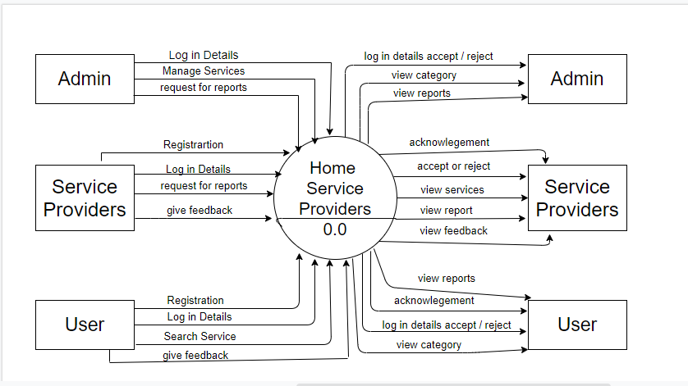

First Level DFD:

**Admin**:

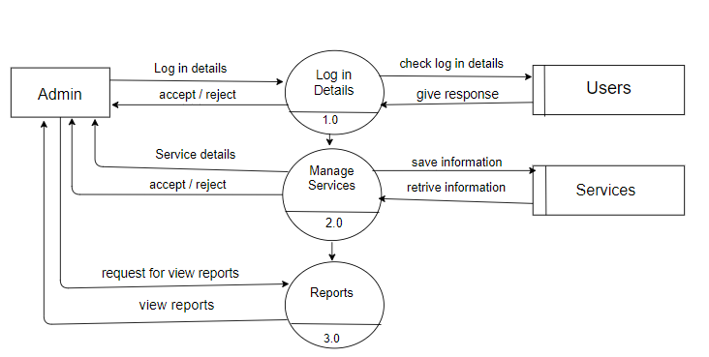

**User:**

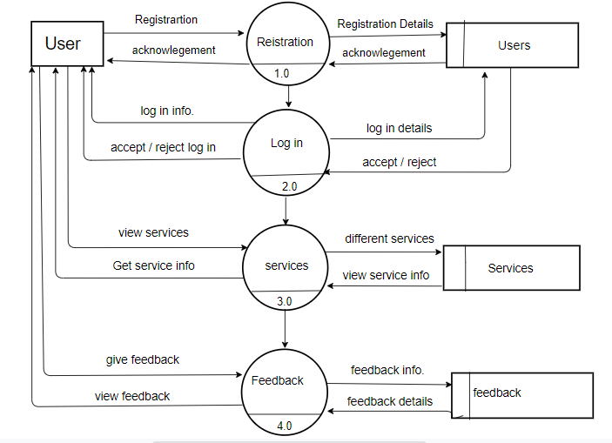

**Service Providers :**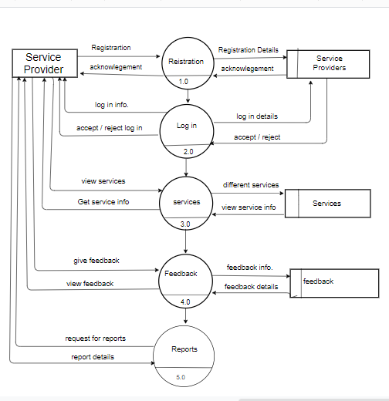

**3.2 ERD (Entity Relationship Diagram):**

ER diagram For Home Service Provider

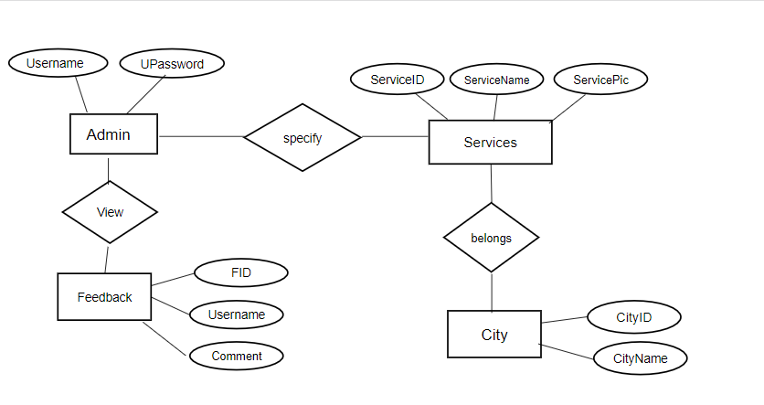

**3.3 Database Design**

|  |  |  |  |
| --- | --- | --- | --- |
| **Roles** | 1:Admin 2:User 3:ServiceProvider | | |
|  |  |  |  |
| **Column Name** | **Data Type** | **Constraint** |
| RoleID | int (P.K.) | P.K. |
| RoleName | varchar(50) |  |

|  |  |  |  |
| --- | --- | --- | --- |
| **Services** |  |  |  |
|  |  |  |  |
| **Column Name** | **Data Type** | **Constraint** |
| ServiceID | int | P.K. |
| ServiceName | varchar(100) |  |
| ServicePic | varchar(max) |  |

|  |  |  |  |
| --- | --- | --- | --- |
| **Users** | |  |  |
|  |  |  |  |
| **Column Name** | **Data Type** | **Constraint** |
| UserID | numeric(18,0) | P.K. |
| Username | varchar(50) |  |
| UPassword | varchar(10) |  |
| RoleID | int | F.k. |
| FullName | varchar(100) |  |
| Gender | varchar(10) |  |
| MobileNo | numeric(18,0) |  |
| SecQue | varchar(100) |  |
| SecAns | varchar(100) |  |
| CityID | int |  |
| Dated | date |  |
| Address | varchar(100) |  |
| Active | bit |  |

**Feedback**

|  |  |  |
| --- | --- | --- |
| **Column Name** | **Data Type** | **Constraints** |
| FID | int | P.K. |
| RoleID | int | F.K. |
| Username | varchar(50) |  |
| FullName | varchar(50) |  |
| EmailID | varchar(50) |  |
| Comment | varchar(100) |  |
| Dated | date |  |

|  |  |  |  |  |  |  |  |  |  |  |  |  |  |  |  |  |  |  |  |
| --- | --- | --- | --- | --- | --- | --- | --- | --- | --- | --- | --- | --- | --- | --- | --- | --- | --- | --- | --- |
| |  | | --- | | **City** | | **Column Name** | | **Data Type** | **Constraints** | | CityID | | int | P.K. | | CityName | | varchar(50) |  |   **ServiceProviders** | | |  | |  | |
|  |  | |  | |  | |
| **Column Name** | | **Data Type** | | **Constraint** | |
| SPID | | numeric(18,0) | | P.K . | |
| ServiceID | | int | |  | |
| Username | | varchar(100) | |  | |
| UPassword | | varchar(10) | |  | |
| RoleID | | int | | F.k. | |
| FullName | | varchar(100) | |  | |
| Gender | | varchar(10) | |  | |
| MobileNo | | numeric(18,0) | |  | |
| SecQue | | varchar(100) | |  | |
| SecAns | | varchar(100) | |  | |
| CityID | | int | |  | |
| Dated | | date | |  | |
| Address | | varchar(100) | |  | |
| SPPic | | varchar(max) | |  | |
| Active | | bit | |  | |

**3.4 Ouput Screen**

**1.Log in**

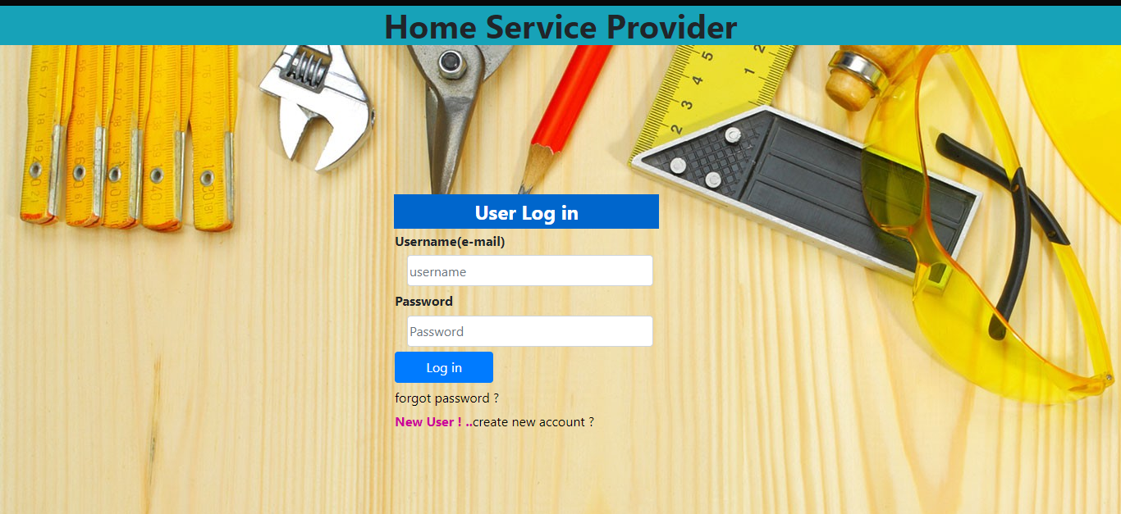

**2.Register**

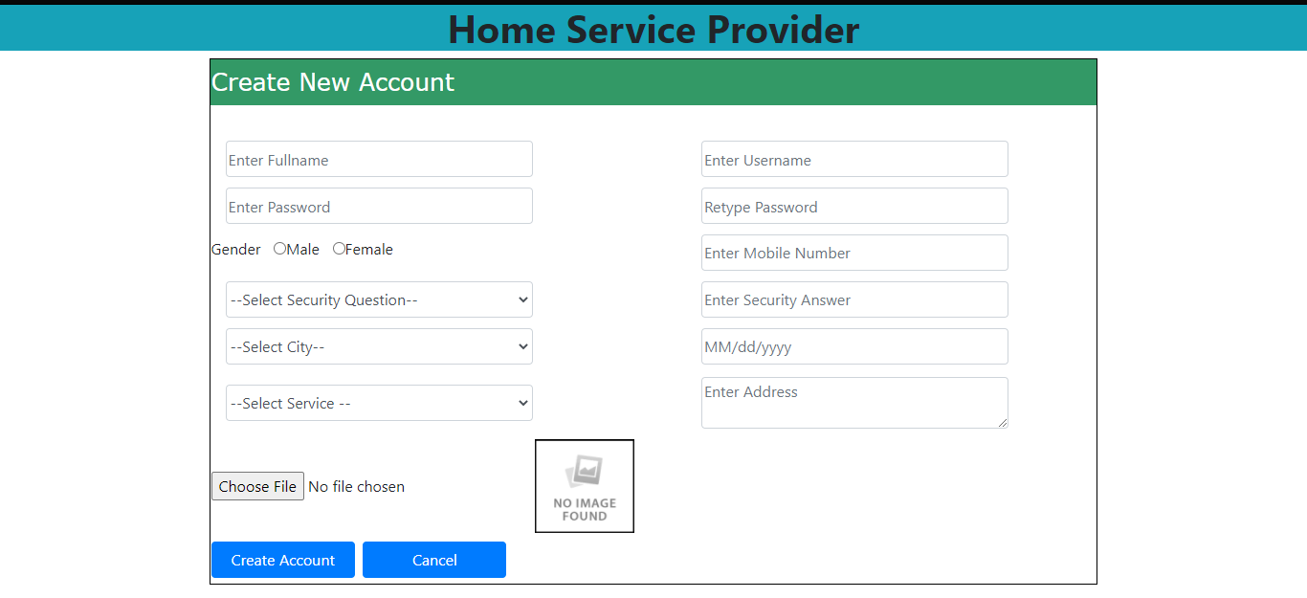

**3.Add new service**

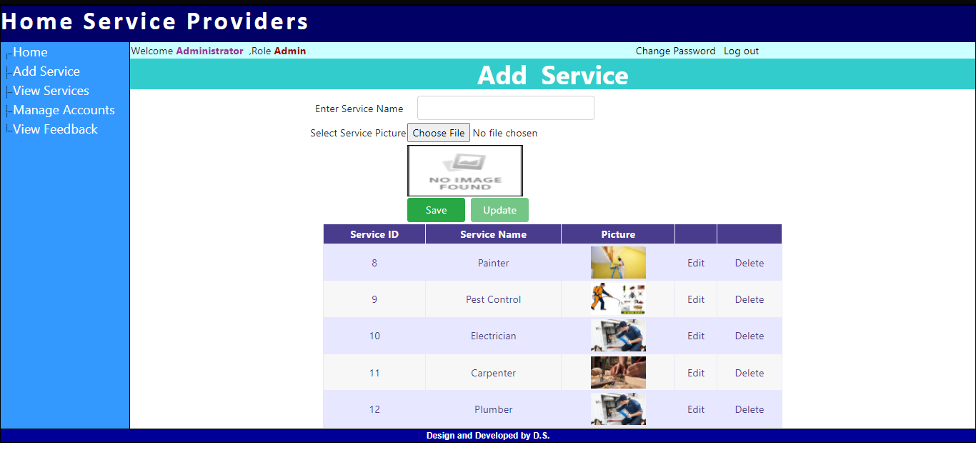

**4.View Services**

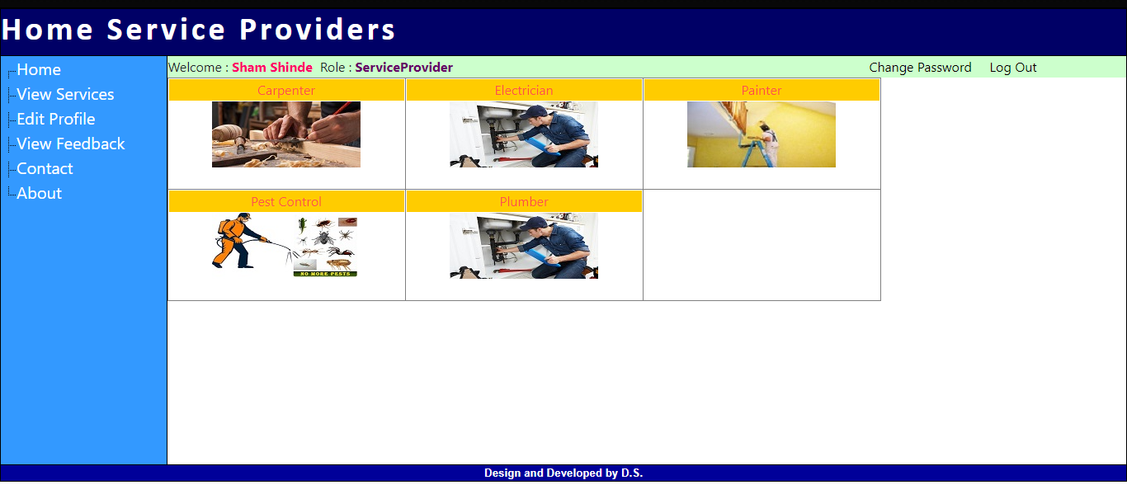

**5.Find Service Provider**

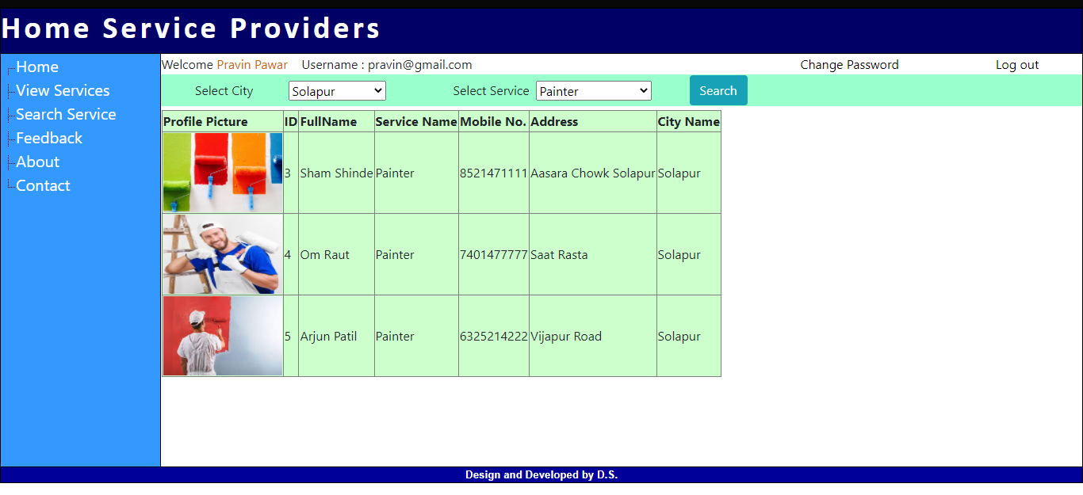

**6.Give Feedback**

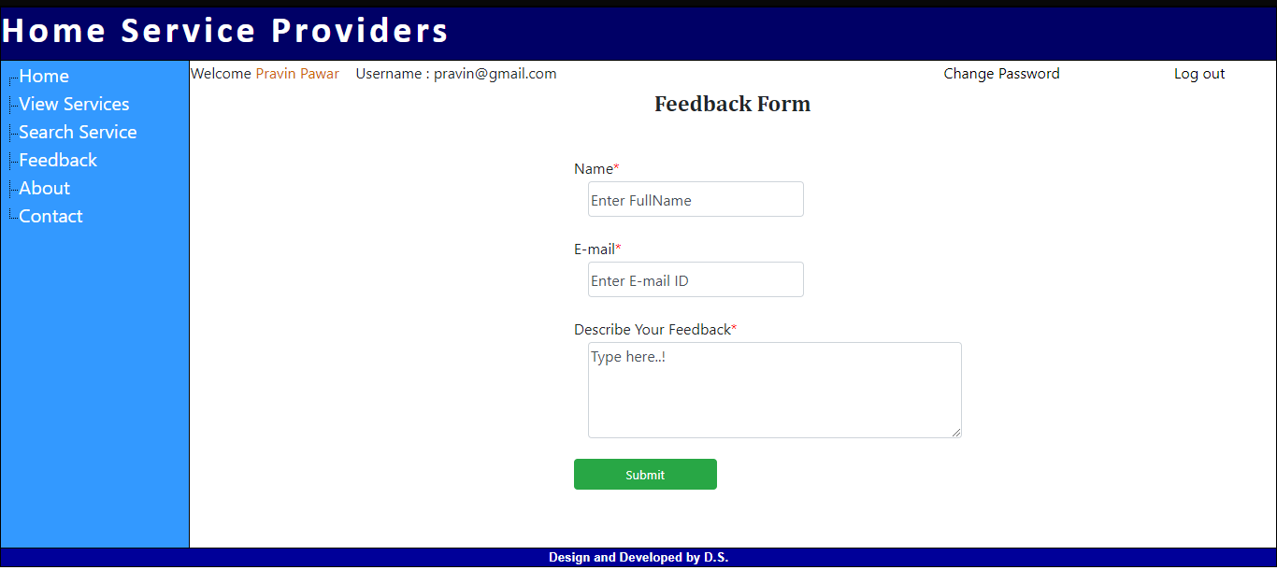

**4.Implementation:-**

**4.1 : Code Script**

using System;

using System.Data;

public partial class User_UserSignUp : System.Web.UI.Page

{

protected void Page_Load(object sender, EventArgs e)

{

}

string gender;

protected void btnCreateAccount_Click(object sender, EventArgs e)

{

if (rdbMale.Checked)

{

gender = rdbMale.Text;

}

else

{

gender = rdbFemale.Text;

}

try

{

// to check username is already exist or not

string strcmd = "select UserID " +

" from Users " +

" where (Username = '" + txtUsername.Text + "')";

DataTable dt = new DataTable();

dt = SqlHelper.FillData(strcmd);

if (dt.Rows.Count > 0)

{

// username is already exist

lblMsg.Text = "username is not available";

}

else

{

SaveUser(strcmd);

}

}

catch (Exception ex)

{

throw ex;

}

}

private void SaveUser(string strcmd)

{

try

{

// create account

string strCmd = "INSERT INTO Users " +

" (Username, UPassword, RoleID, FullName, Gender, MobileNo, SecQue, SecAns, CityID, Dated, Address, Active) " +

" VALUES(";

strCmd += "'" + txtUsername.Text + "',";

strCmd += "'" + txtPassword.Text + "',";

strCmd += "2,";

strCmd += "'" + txtFullName.Text + "',";

strCmd += "'" + gender.ToString() + "',";

strCmd += "'" + txtMobileNo.Text + "',";

strCmd += "'" + ddlSecQue.Text + "',";

strCmd += "'" + txtSecAns.Text + "',";

strCmd += "'" + ddlCity.Text + "',";

strCmd += "'" + txtCalendar.Text + "',";

strCmd += "'" + txtAddress.Text + "',";

strCmd += "1)";

SqlHelper.ExecuteNonQuery(strCmd);

MultiView1.ActiveViewIndex = 1;

}

catch (Exception ex)

{

throw ex;

}

}

}

**5.Tools and Technology:-**

1. **Visual Studio 2015:**

Visual Studio 2015 comes with .NET Framework 4 and supports developing applications targeting Windows 10. It supports IBM DB2 and Oracle databases, in addition to Microsoft SQL Server. It has integrated support for developing Microsoft Silverlight applications, including an interactive designer.

Visual Studio 2015 features a new Help System replacing the MSDN Library viewer. The Help System is no longer based on Microsoft Help 2 and does not use Microsoft Document Explorer. Dynamic help containing links to related help topics based on where the developer was in the IDE has been removed in the shipping product, but can be added back using a download from Microsoft.

1. **SQL Server Express:**

Microsoft SQL Server Express is a version of Microsoft's SQL Server relational database management system that is free to download, distribute and use. It comprises a database specifically targeted for embedded and smaller-scale applications. The product traces its roots to the Microsoft Database Engine (MSDE) product, which was shipped with SQL Server 2000. The "Express" branding has been used since the release of SQL Server 2014.

**6. Bibliography and References:**

* www.Csharpcorner.com
* .<http://WWW.w3schools.com>